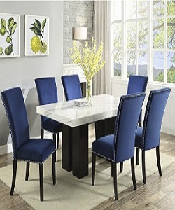

Modern Dining Table

$156.86

Availability: In stock

Description

Steve Silver Camila Dining Table Base with Modern Steve Silver Camila Blue Dining Chair with Nail head. A simple, round tabletop sites atop a marble base with wood legs.